Front end developer – coding test

Develop a single-page web application using HTML5, CSS3 and Angular (version 4.0.0 or later), that displays exchange rates for a currency on a given date. The page should contain a drop-down menu for base currency selection (user can choose from EUR, USD, GBP, AUD, CAD and JPY), an input for date selection, a submit button and a table for displaying exchange rates. The table should contain three columns, one for the currency code and two for the buy/sell rates. User must be able to alphabetically sort the rows in the table based on the currency code by clicking the currency column header, switching between ascending and descending order. Following mockup shows the desired page layout:

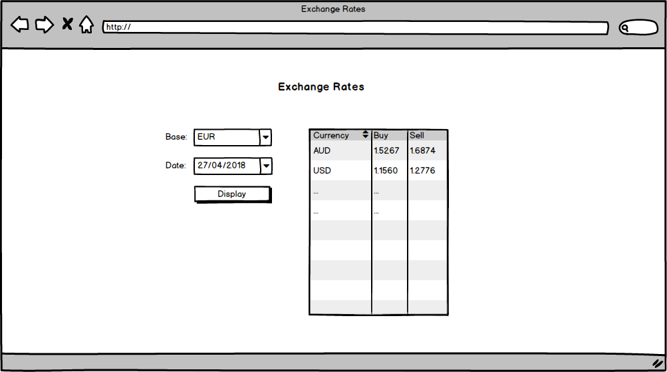

As the data source, use the public API <https://exchangeratesapi.io/>. This API provides exchange rates published by the European Central Bank (ECB). We need to create the buy/sell rates from the ECB rates in a way that we subtract 5% from the ECB rate to get our buy rate and we add 5% to get our sell rate. All rates should be displayed with exactly four decimal places. Highlight the currencies in the table, that can be selected as a base from the drop-down (make the font color on the whole row red).

Don’t use any 3rd party components or libraries to accomplish this task. Create all the necessary components and services in Angular, use HTML5 and CSS3 for markup and styling. If you don’t know Angular you can use other JavaScript framework as well. Graphical design is not required, just follow the layout as shown on the mockup and keep the elements plain (or style them as you wish).